**Tribhuvan University**

**Asian School of Management and Technology**



**Book Recommendation System using Collaborative Filtering**

**Course Code: CSC-412**

**A Project Proposal for the Final Year Project submitted to the particular fulfilment of the requirement for the degree of Bachelor of Science in Computer Science and Information Technology awarded by Tribhuvan University.**

**Submitted By:**

Rabin Neupane (TU Exam Roll No.24109 /076)

Sushil Shrestha (TU Exam Roll No.24127 /076)

Ritesh Rc (TU Exam Roll No. 24114/076)

**Submitted to**

**Department of Computer Science and Information Technology**

**Asian School of Management and Technology**

**Institute of Science and Technology**

**Tribhuvan University**

**1. Introduction**

. Book

Recommendation System (BRS) recommends a set of books to

users based on their previous ratings.

Book Recommendation System (BRS) is a type of system that suggests books to users based on their preferences, interests, and behavior. A book recommendation system recommends a set of books to users based on their previous ratings. The primary goal of a book recommendation system is to enhance the user experience by providing personalized suggestions, making it easier for users to discover books that align with their interests. Book recommendation systems are widely used by online platforms that provide e-books, such as Google Play Books, Open Library, Goodreads, etc. Book recommendation systems can help users discover new books, enhance their reading experience, and increase their satisfaction and loyalty.

**2. Problem Statement**

In the vast realm of literature, discovering the next captivating read can be a challenge, and traditional recommendation methods often fall short. To address this, we propose the development of an advanced book recommendation system that leverages cutting-edge algorithms and user data to provide tailored suggestions. This system will analyze individual reading habits, genre preferences, and past interactions with books to generate personalized recommendations, ensuring a more engaging and enjoyable literary experience. Users will navigate an intuitive interface, effortlessly exploring curated suggestions that align with their unique tastes. Whether seeking a thrilling mystery, a thought-provoking non-fiction piece, or a heartwarming novel, the book recommendation system aims to revolutionize the way readers discover and connect with literature, ushering in a new era of personalized and enriching reading experiences.

**3. Objectives**

Major objectives of our project are:

1. To improve the accuracy of book tracking.
2. To predict reader’s interest and recommend books to them accordingly.
3. To recommend relevant books to users based on popularity and user interests.

**4.Methodology**

The primary wellspring of insights for developing the book recommendation system stemmed from direct interactions with readers, involving in-depth conversations about their literary experiences and preferences. Engaging individuals in discussions about their book choices, genres of interest, and reading habits provided valuable firsthand information.

1. **Requirement Identification**

The leave management system is a system that aims to provide the facility of sending leave request and accept or decline those request. The system will use priority based scheduling algorithms to schedule various leave request. The system will consist of a web-based interface allowing users to send leave request with the required amount of leave days.

* + 1. **Literature Review**

The Leave Management System automates the process of managing and tracking multiple types of employee leaves. Employees are able to submit the leave form, cancel previously submitted leave requests, check the status of leave requests and view completed leave transactions. The Leave Management System maintains a database to keep a running balance of each employees account, accrues employee vacation and sick credits and provides individual reports on employees leave accruals.[3]  
  
Traditionally, human resource manager of an organization used to keep record of employee’s leave manually in book record which obviously was not effective way. With the improvement and evolution of technology, multiple system has been developed for keeping track of employee’s leave record. One of the similar system is calamari which manages employee’s day off, vacation or leaves to maintain employees record in company. Another similar system is actiPLANS [3]. It is leave and work management software that helps businesses manage time off, work shifts, project activities, employee locations, events etc. Its users can manage leave requests and leave balances, review team availability, plan out project activities, assign work shifts . Similarly, Improved Leave Scheduling Algorithm For Improved Service Delivery In The Nigerian University System is another project on leave management. In its working mechanism, it is an algorithm that assesses leave requests and schedules the leave requested for periods having least impact on staff mix by rank and lecturer-to-students ratio. In the Nigerian university system, leave can be managed to avail academic staff for training, research and even rest. In pursuance of these, human resource planners may overcommit staff to it, leaving the system understaffed at key moments, or under commit to it and lose out on the benefits.[3]

* + 1. **Requirement Analysis**

Since the system is leave management system, it should be able to manage employee’s leave in the organization. This may require the use of priority based allocation and clustering technique. Using the system employee of an organization should be able to send leave request to the supervisor and the supervisor should be able to either approve or decline those requests. The system should be able to evaluate employee according to their leave days. Not only that the system should also be able to maintain the attendance of an employee. Lastly the system should be user friendly and cost-effective.

1. **Feasibility Study**

Before developing a new project, we have to investigate and analyze the feasibility of the project. It is done to assess the potential of a project.

The feasibility study of this project is divided into four major categories depending upon the distribution of time and availability of resources. They are given as below:

* 1. **Technical**

This is web-based application which uses priority based scheduling to schedule list of employee’s leave. The leave can be approved on the basis of leave’s priority or the number of leave days that employee has requested for. Since the system is simple and don’t require any external devices for functioning we will be able to construct this system using resources available in internet and our existing knowledge of technologies.

* 1. **Operational**

This system aims at making it easier for employees to request time off and for managers to approve or deny those requests. For that the system must be accessible to employee and supervisor working at the particular organization. The organization must implement the system. After implementation the system can be easily used. Apart from this, no prerequisite is required.

* 1. **Economic**

This system will be constructed at a minimum price. Almost every resource required for the system will be acquired from the internet. We will be able to do this project using our understanding of available languages and technologies.

* 1. **Schedule**

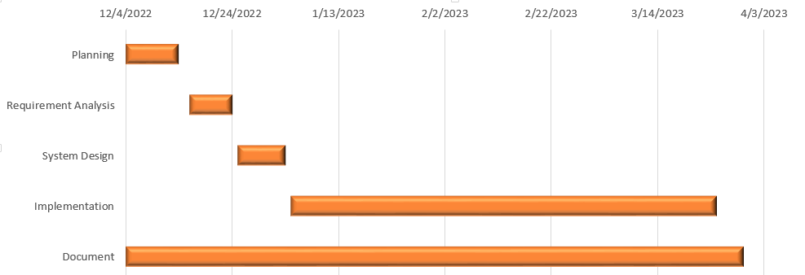

Figure: Gantt Chart

The above Gantt chart diagram represents the time taken for the completion of the project and the time consumed by the each activity in the following days. It shows the time taken by the Planning for the entire ten days, then after that requirement analysis has taken more than one week respectively. Similarly, system design, implementation and document is shown in the Gantt chart. Implementation has taken the most time.

1. **High Level Design of System**

A leave management system is a system that employers use to allow employees to request leave and supervisors to approve requests made by employees. When the user enters the system, the system detects the user by scanning their face and they can be marked as present for attendance. Employee can apply for leave by choosing the date for leave and request the supervisor for leave .There will be different category for leave such as sick leave, maternity leave, vacation leave, compensation leave, etc. and the user can choose the reason behind their leave from leave category and also send valid reason behind it. The authority for leave approval or declination depends on supervisor or department head. The leave can be approved on the basis of leave’s priority or the number of leave days that employee has requested for .The system helps to evaluate employee on the basis of their present days in a month and evaluate their performance as well. This process helps in the payroll process.

1. **Use Case Diagram**

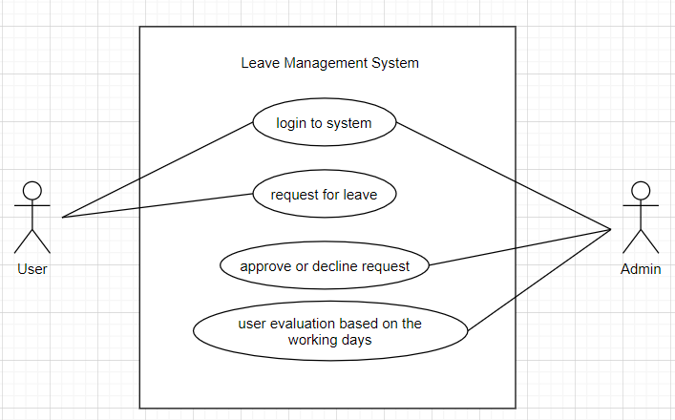

Fig: Use case diagram of Leave Management System

1. **Flowchart**

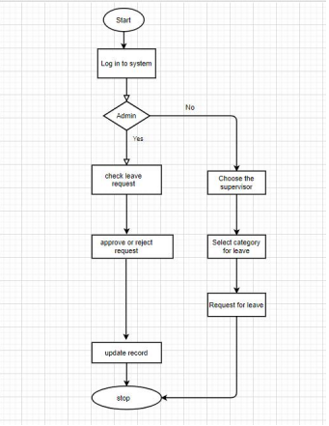

Fig: Flow Chart of Leave Management System

**5. Expected Outcome**

The expected outcome for a Leave management system project would be the development of a system with the feature of login with face recognition, attendance for leave tracking and the system with the feature which allow user to send leave request successfully and approve or decline those requests. With the help of developed system we would also be able to evaluate employee.

**6. References**

[1] Rushitha, E., Preethi, G., Harshita, N.M., Manisha, R.R. and Veena, M. (2019). Android Leave Management System. International Research Journal of Computer Science. 06(6).

[2] Adamu A.(2020). EMPLOYEE LEAVE MANAGEMENT SYSTEM Article  in  FUDMA Journal of Sciences

[3] B.U. Stephen G.A. Chukwudebe D.O.Dike N Chukwudebe(2018). Improved leave scheduling algorithm for improved service delivery in the Nigerian university system